-Chapter 21

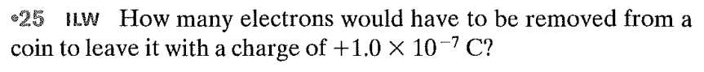

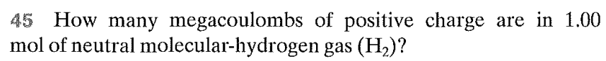

Questions:

